Code :

const express = *require*('express');

const axios = *require*('axios');

const port = 8008;

const app = *express*();

app.*use*(express.*json*());

app.*get*('/numbers', async (req, res) => {

  const urls = req.query.url;

  if (!urls || !Array.*isArray*(urls)) {

    return res.*status*(400).*json*({ error: 'No valid URLs provided' });}

  const allnum = [];

  async function *fetchData*(url) {

    try {

      const response = await axios.*get*(url, { timeout: 5000 });

      const data = response.data;

      if (Array.*isArray*(data.numbers)) {

        allnum.*push*(...data.numbers);

      }} catch (error) {

      console.*error*(` unknown error form ${url}: ${error.message}`);

    }}

  await Promise.*all*(urls.*map*((url) => *fetchData*(url)));

  const unisortnum = [...new *Set*(allnum)].*sort*((a, b) => a - b);

  res.*json*({ numbers: unisortnum  });

});

app.*listen*(port, () => {

  console.*log*(`${port} runs on this port`);

});

This is the output for [http://localhost:8008/numbers?url=http://20.244.56.144/numbers/primes&url=http://20.244.56.144/numbers/fibo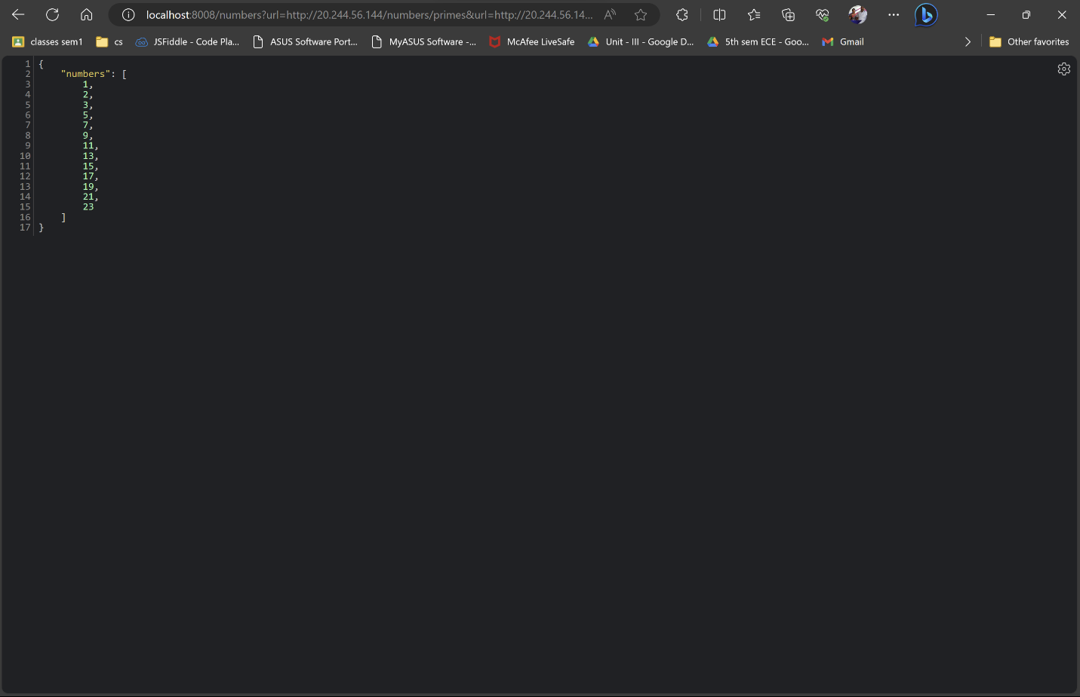](http://localhost:8008/numbers?url=http://20.244.56.144/numbers/primes&url=http://20.244.56.144/numbers/fibo)

Other example

